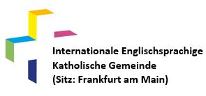
Church location (please mark respectively):
St. Mary’s in Liederbach ☐
St. Leonhard’s in Frankfurt-Ctiy ☐
Holy Cross in Frankfurt-Bornheim ☐
Parish Registration Form
This form is only for internal use. If you like to be registered officially in the registry of the Catholic German Church, please contact our parish office
(PLEASE PRINT IN BLOCK/CAPITAL LETTERS)

NAME

Nationality

Email address where you would like to receive the parish bulletin

Home Address – Street + Number Postal/Zip Code City

Phone number

Date of Birth //
Name 1 Day Month Year

Date of Birth //
Name 2 Day Month Year

Date of Birth //
Name of Child 1 Day Month Year

Date of Birth //
Name of Child 2 Day Month Year

Date of Birth //
Name of Child 3 - Day Month Year

If you are interested in serving one or more ministries, please feel free to contact us.

Please note, that all information provided is for internal parish use only and will not be given to any third party. All registration forms are kept under lock and key at the parish office.

// …………………………………………………………………………………………………………..
Day Month Year Signature

